Bedford Street Surgery
Patient Survey 2014
Excel Report (click here for full dataset)Number of Responses: 158

Patient Survey 2014
Please indicate which practice you are registered at ?
Bedford Street 77%
Furzton 21%
No response 2%
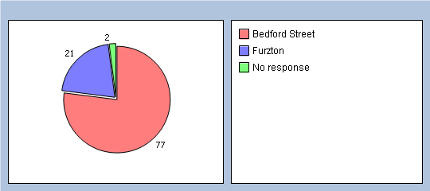
How do you currently book appointments at the practice?
Telephone 74%
Online 0%
Queue at practice 31%
How would you prefer to book appointments at the practice ?
Telephone 70%
Online 22%
Queue at practice 13%
How satisfied are you with the current method of booking appointments?
not satisfied 12%
room for improvement 25%
fairly satisfied 32%
very satisfied. 27%
No response 4%
